**SD3489 - Practical DevOps – CI/CD on Azure**

Table of Contents

[1] Introduction 2

[2] Prerequisites 2

[3] Git Repositories 2

[4] Provisioning infras using Terraform 2

Configure AZ 2

Provisioning Infras 3

Build backend and front-end docker image 8

Apply k8s Yaml templates for backend, front-end, mongodb 10

Get K8s Pod 11

[5] Azure Pipeline 12

[6] ArgoCD 14

Install 14

Sign in to ArgoCD 16

Create an application 17

[7] Monitoring with Prometheus and Grafana 19

Install 19

Import metrics to Dashboard 20

Monitoring via UI (Dashboard) 21

# [1] Introduction

* Provision Azure services using Terraform
* Set up Azure Pipeline for CI/CD
* Setting up Monitoring Prometheus and Grafana.

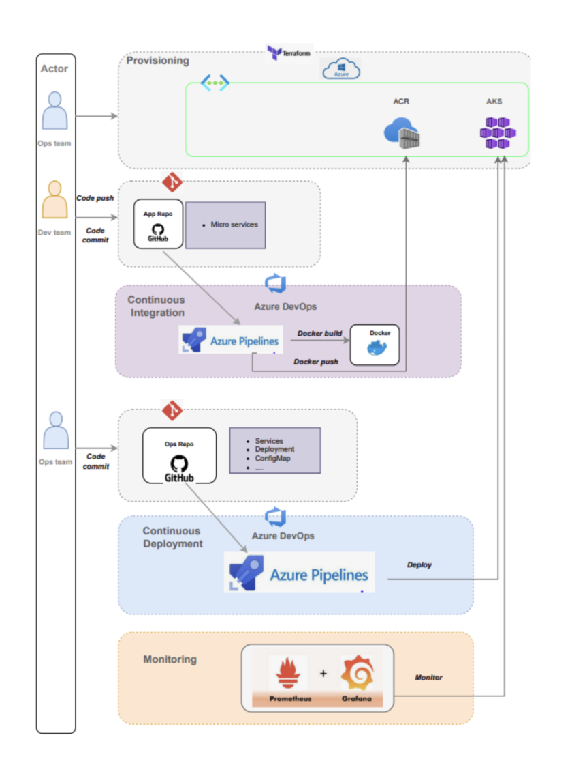

# [2] Prerequisites

* Have an Azure account.
* Azure CLI installed.
* Terraform installed.
* Kubectl installed.
* Helm installled.

# [3] Git Repositories

* Infrastructure (infras) as code
  + <https://github.com/toan-le-theout/sd3489_azure_infrastructure>
* MSA application
  + <https://github.com/toan-le-theout/sd3489_msa>

# [4] Provisioning infras using Terraform

## Configure AZ

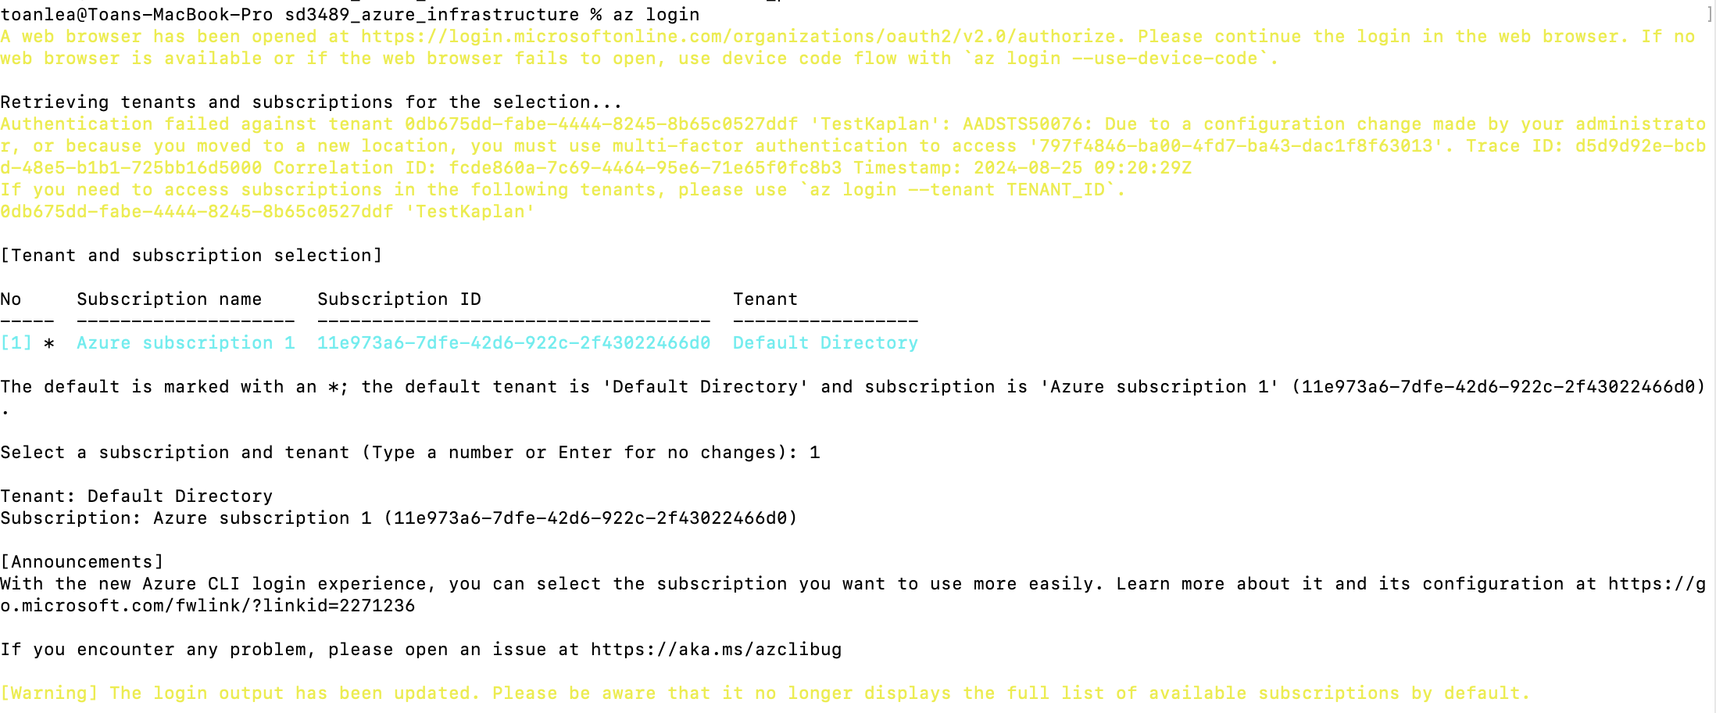

## Provisioning Infras

Clone infras repo from the Github

Go to sd3489_azure_infrastructure, do below steps:

* **terramform init  
    
  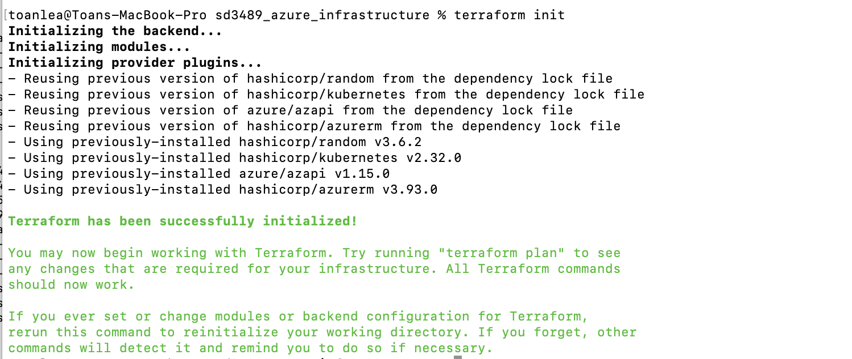**

* **terraform plan  
    
  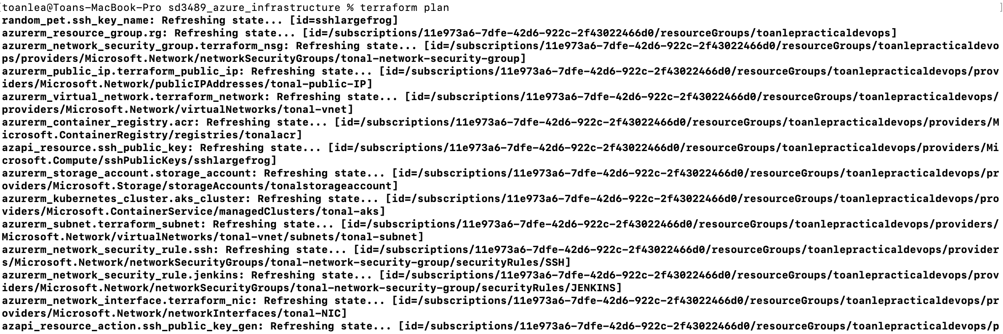**

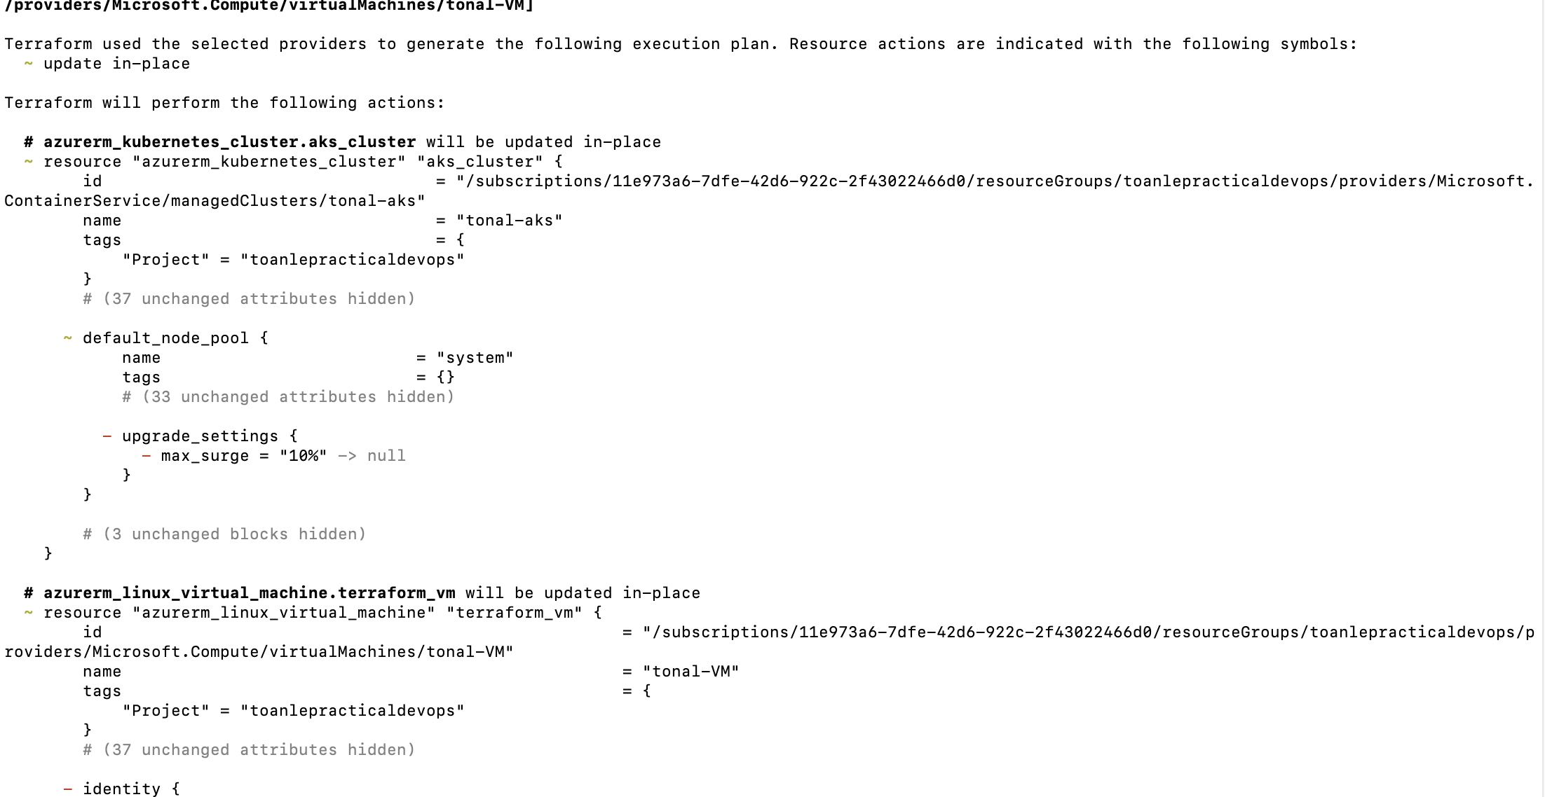

* **terramform apply  
    
  **

**Checking Azure services are provisioned by Terraform**

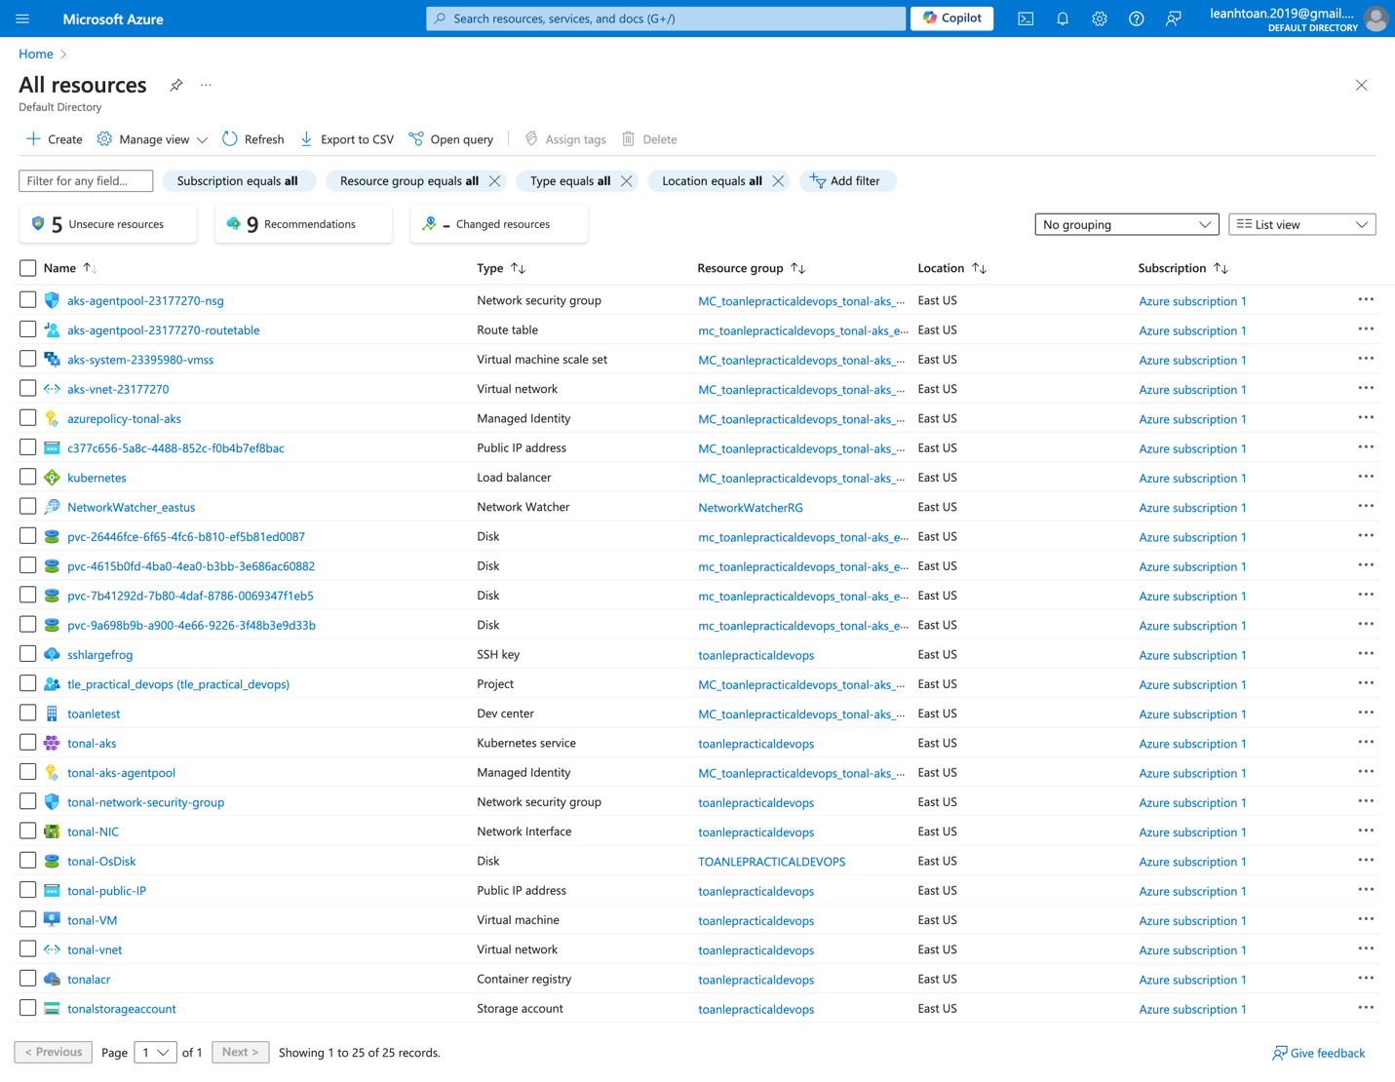

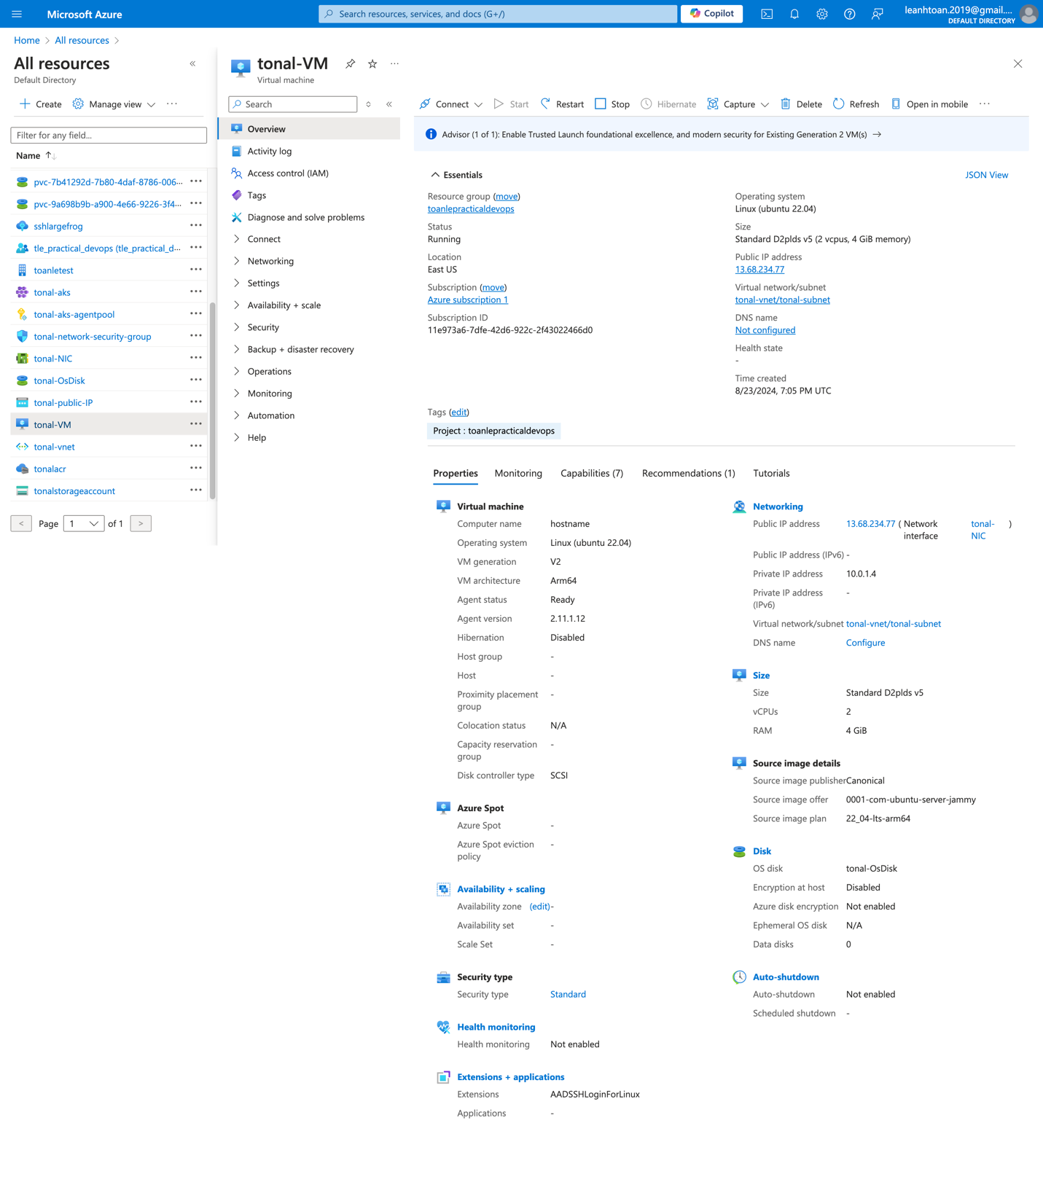

## Build backend and front-end docker image

* Backend image  
    
  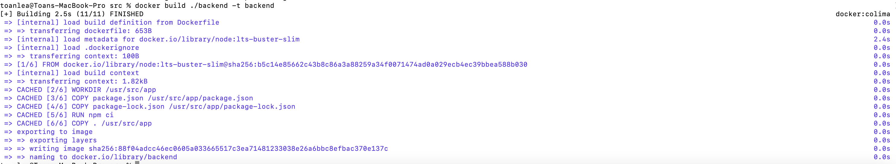
* Front end image  
    
  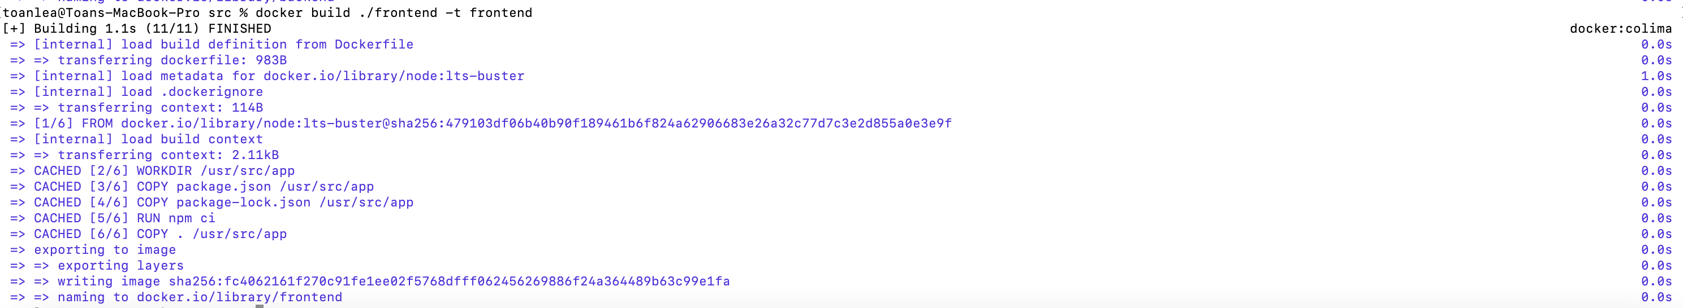





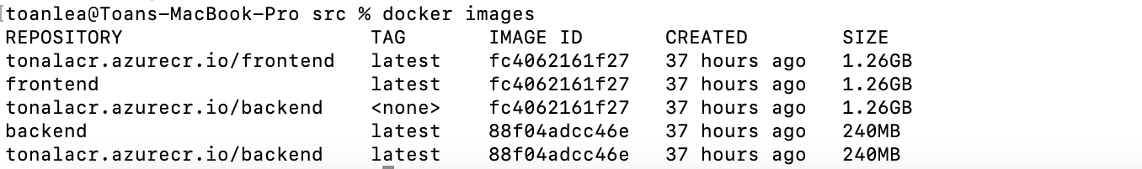

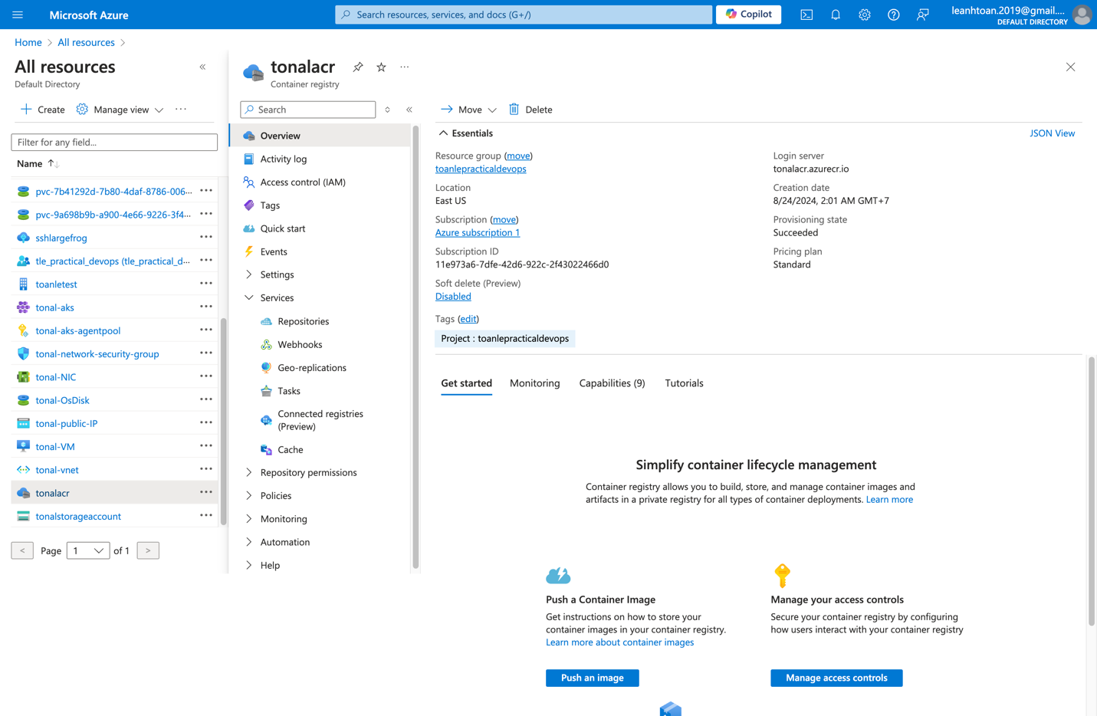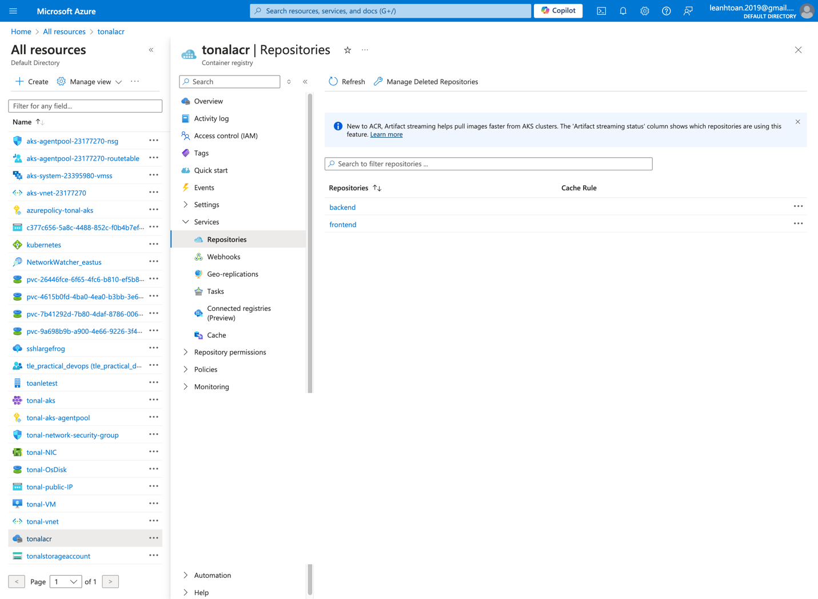

## Apply k8s Yaml templates for backend, front-end, mongodb

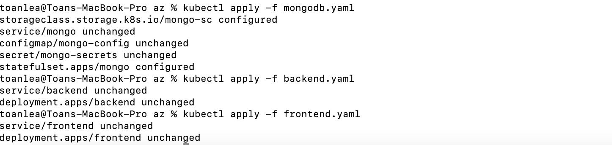

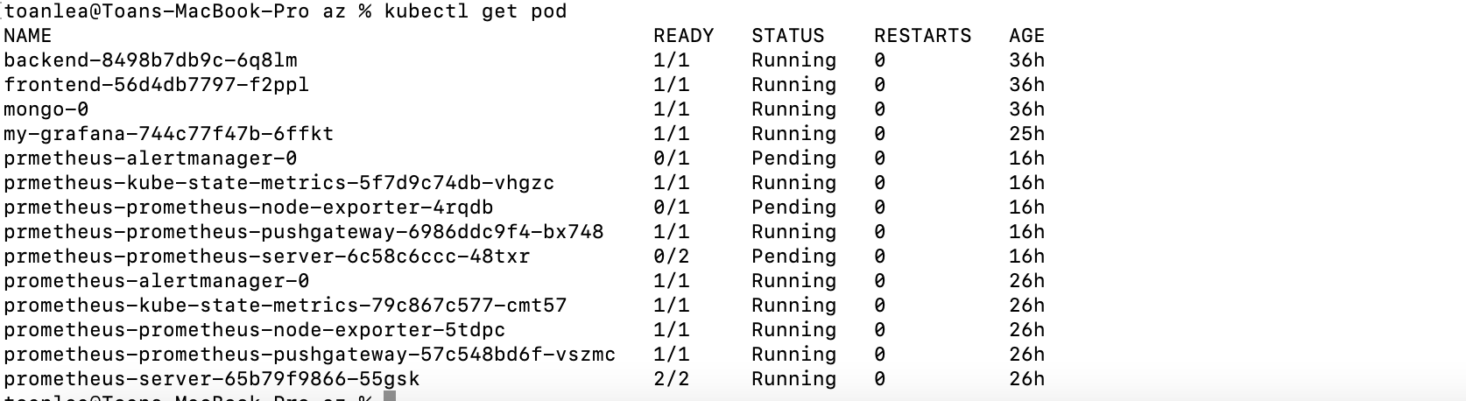

Get credentials for a resource group

```

az aks get-credentials --resource-group toanlepracticaldevops --name toanle-aks --overwrite-existing

kubectl config view --minify | findstr namespace

```

Push docker images (front-end, backend) to Azure Container Registry

```

cd src/backend

docker build -t tonalacr.azurecr.io/backend:latest --push .

cd ../frontend

docker build -t tonalacr.azurecr.io/frontend:latest --push .

```

## Get K8s Pod



**Run front-end service locally**

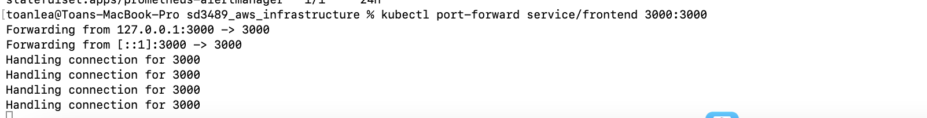

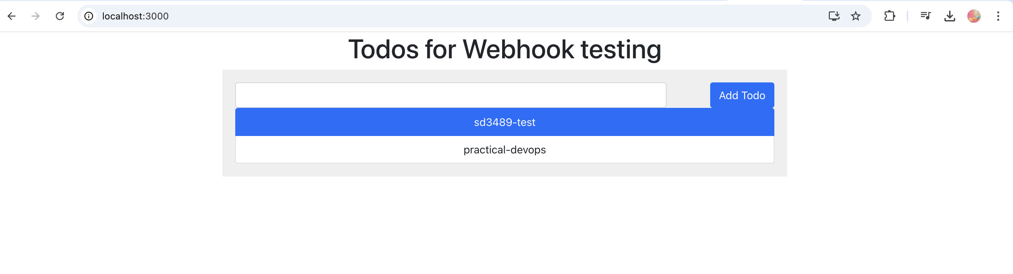

# [5] Azure Pipeline

Create a ServiceConnection

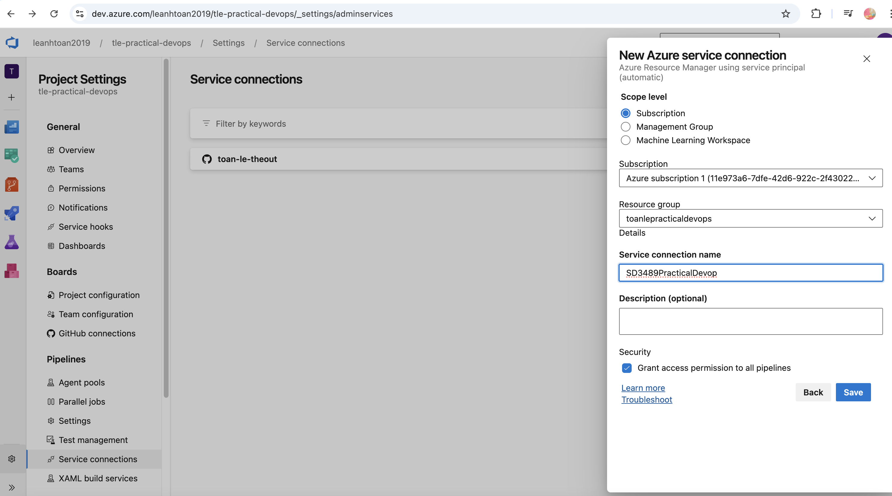

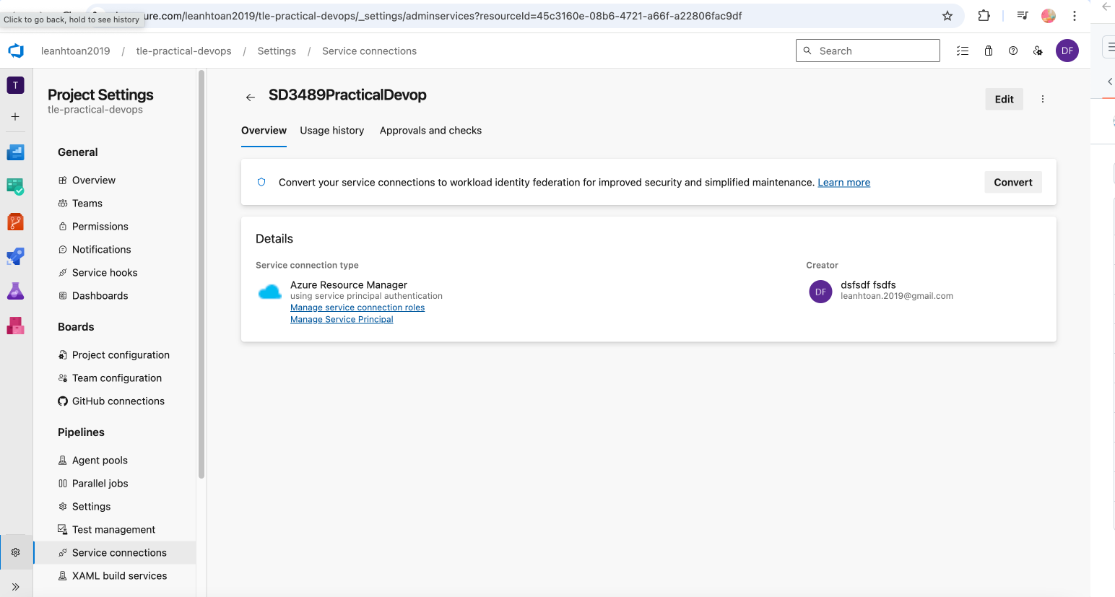

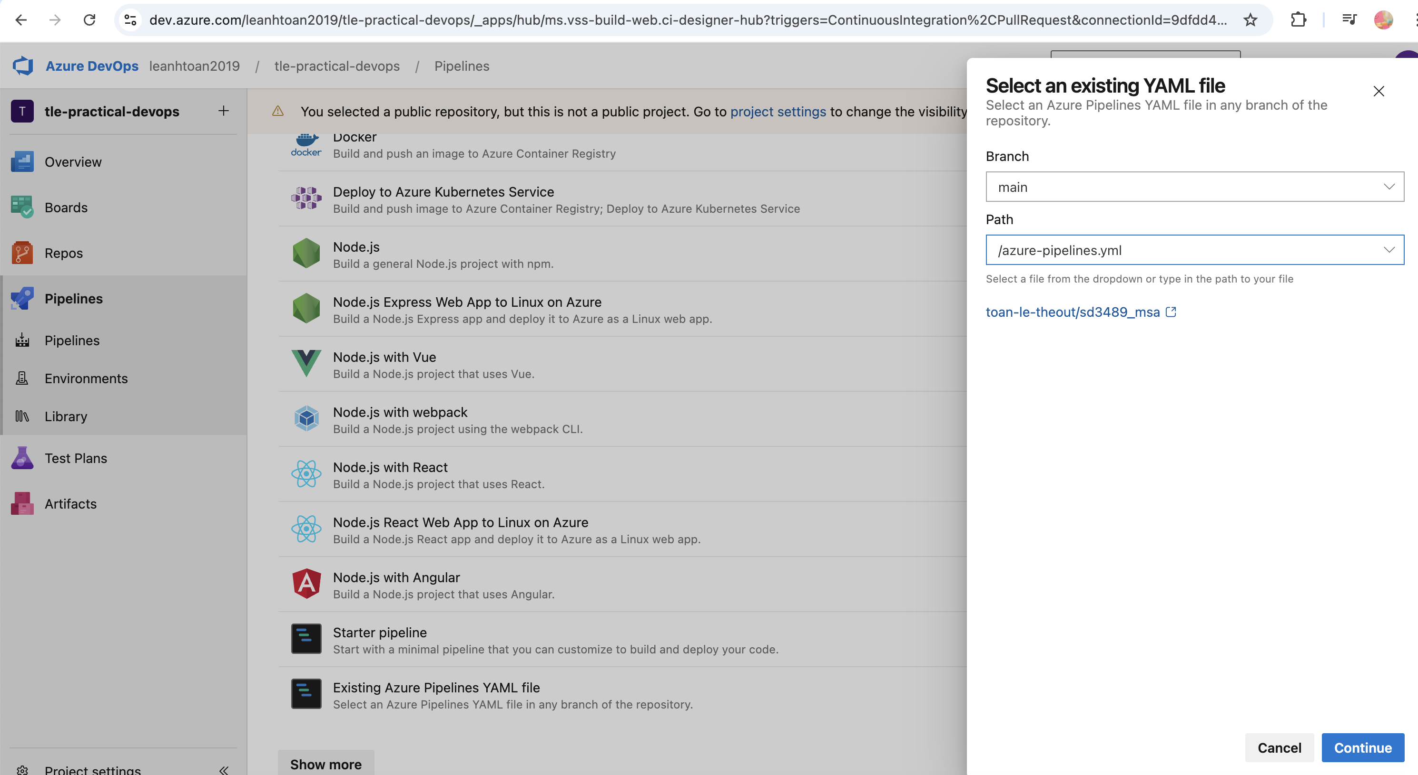

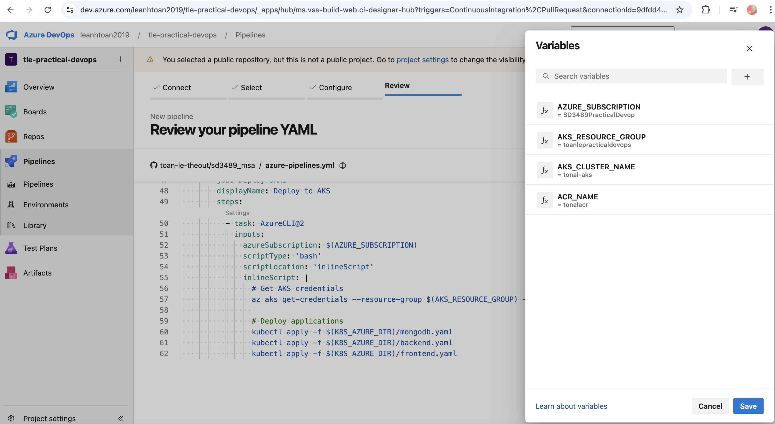

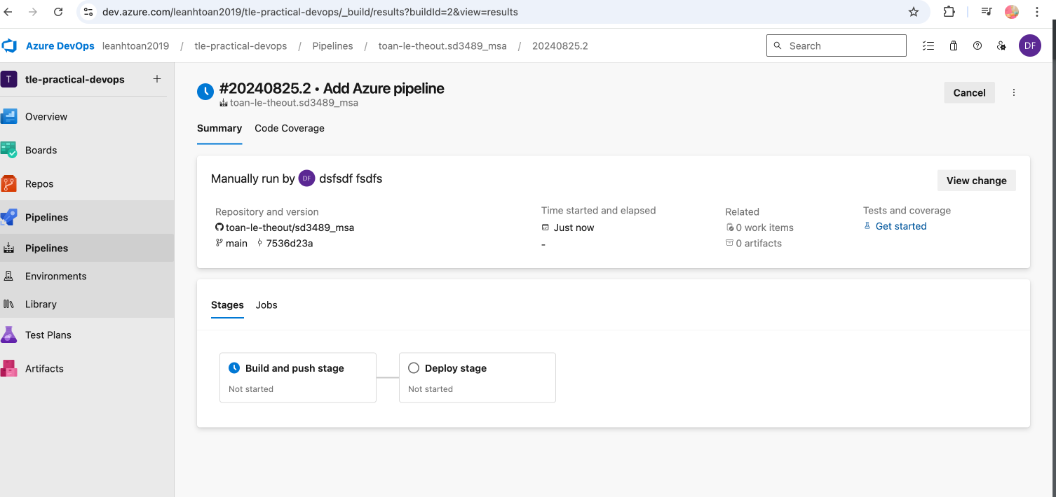

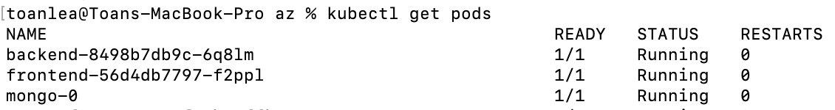

# [6] ArgoCD

## Install

**More details: refer to** [**https://blog.nashtechglobal.com/how-to-create-applications-in-argocd/**](https://blog.nashtechglobal.com/how-to-create-applications-in-argocd/)

* **Create namespace called [argocd]**

Kubectl create namespace argocd

* **Apply YAML file (install all the necessary things)**

**kubectl apply -n argocd -f https://raw.githubusercontent.com/argoproj/argo-cd/stable/manifests/install.yaml**

* **Check pods**

kubectl get pods -n argocd

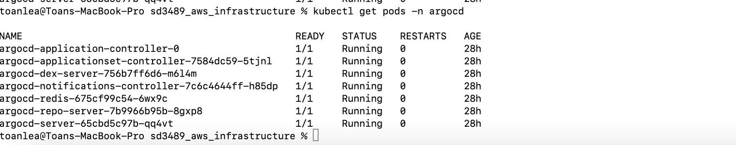

* **Set Port-forward to access locally**

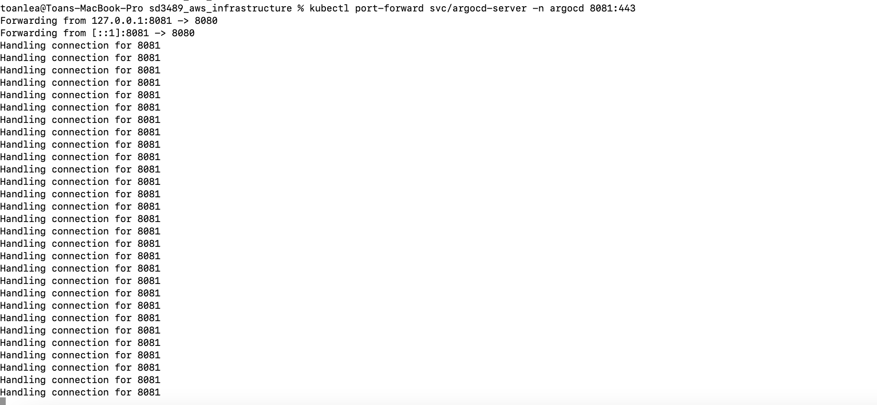

## Sign in to ArgoCD

**https://localhost:8081/**

The password for admin is stored in secret with the name- argocd-initial-admin-secret and also decodes the password.

**Command:**

Getting initial password: kubectl get secrets -n argocd argocd-initial-admin-secret -o yaml   
  
Decode the password: echo ZVF1ZHVZU21OR1RqTFViWg== | base64 --decode

## Create an application

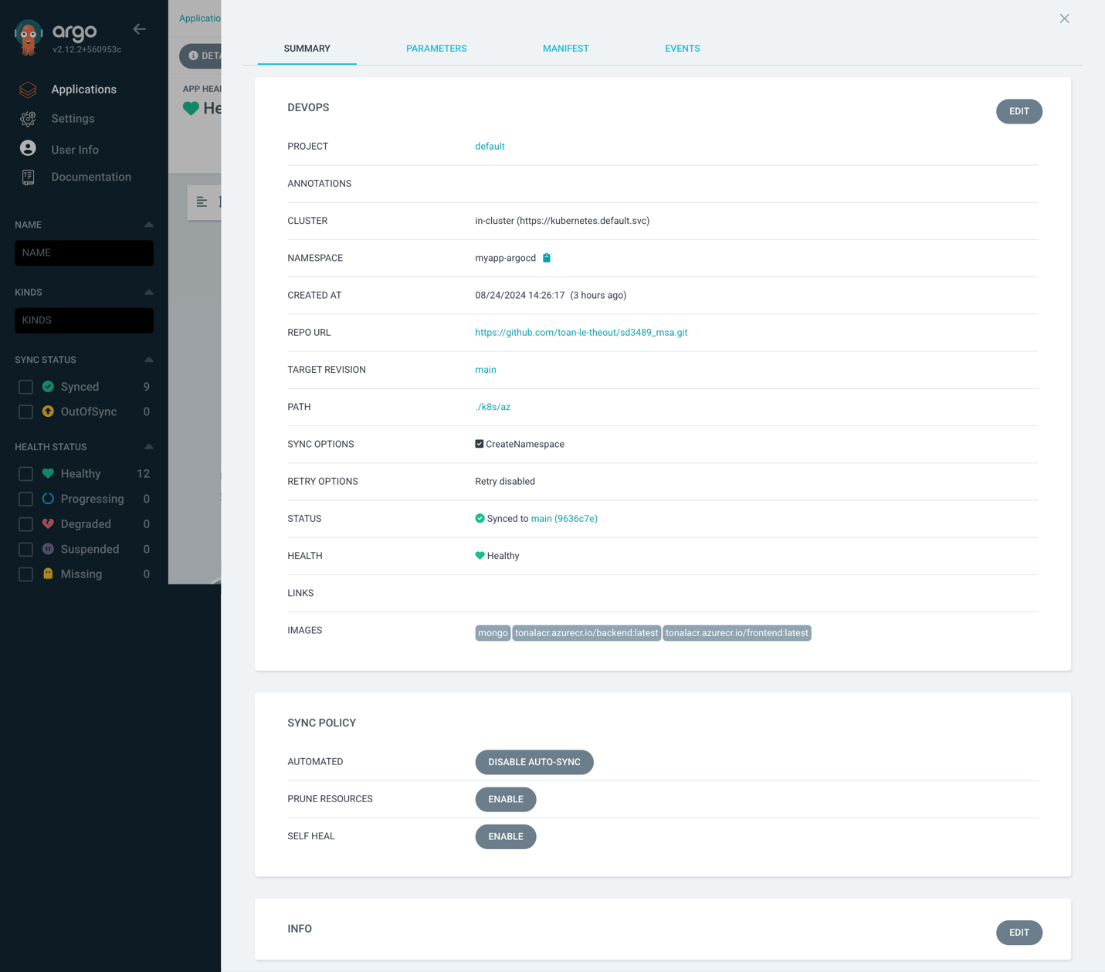

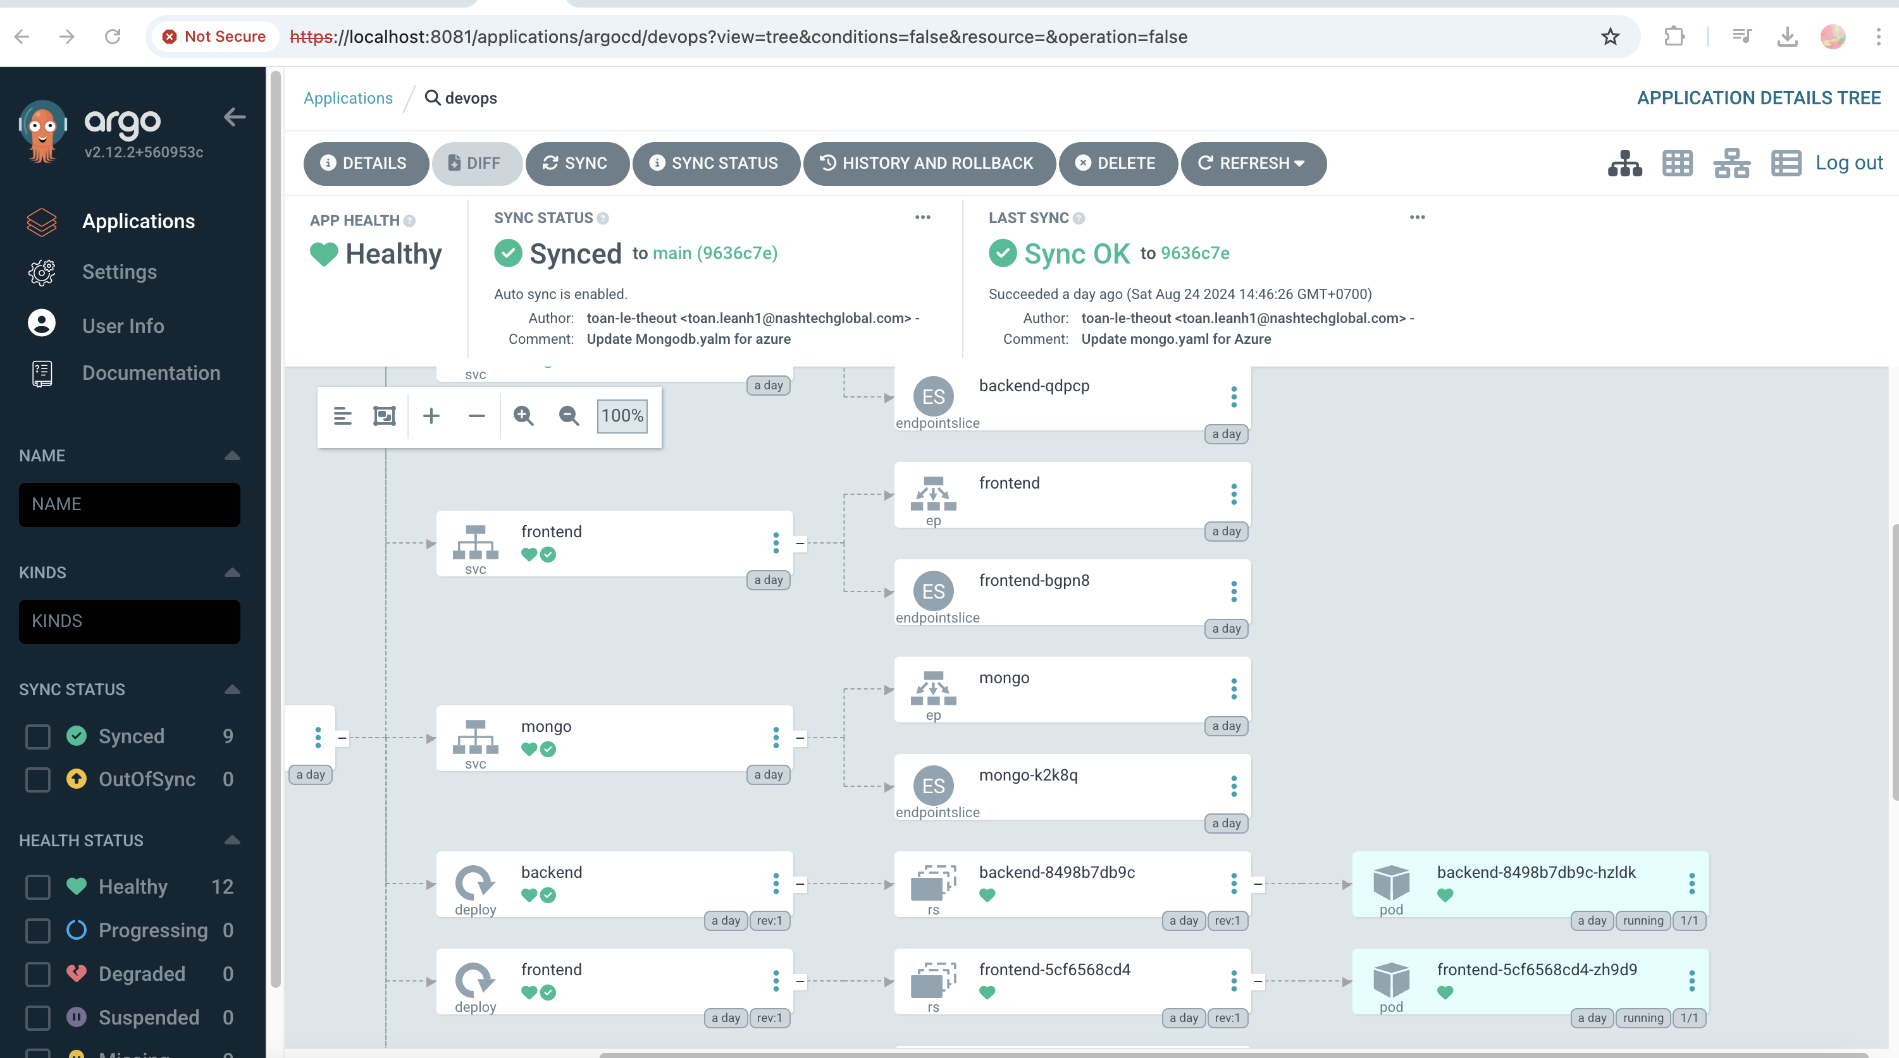

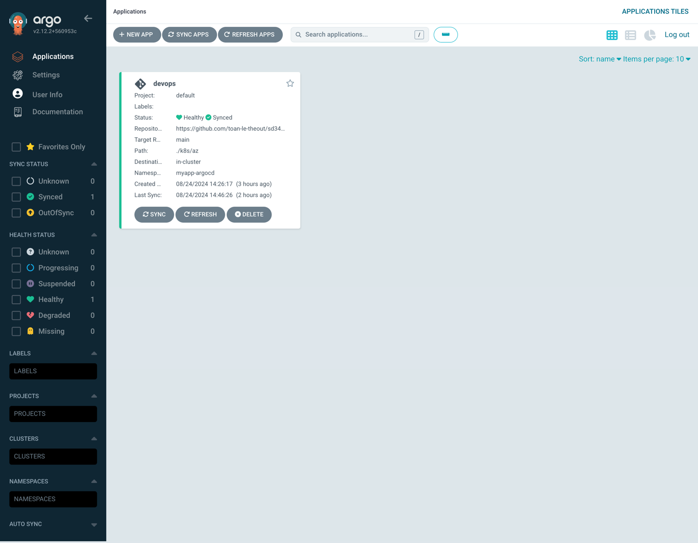

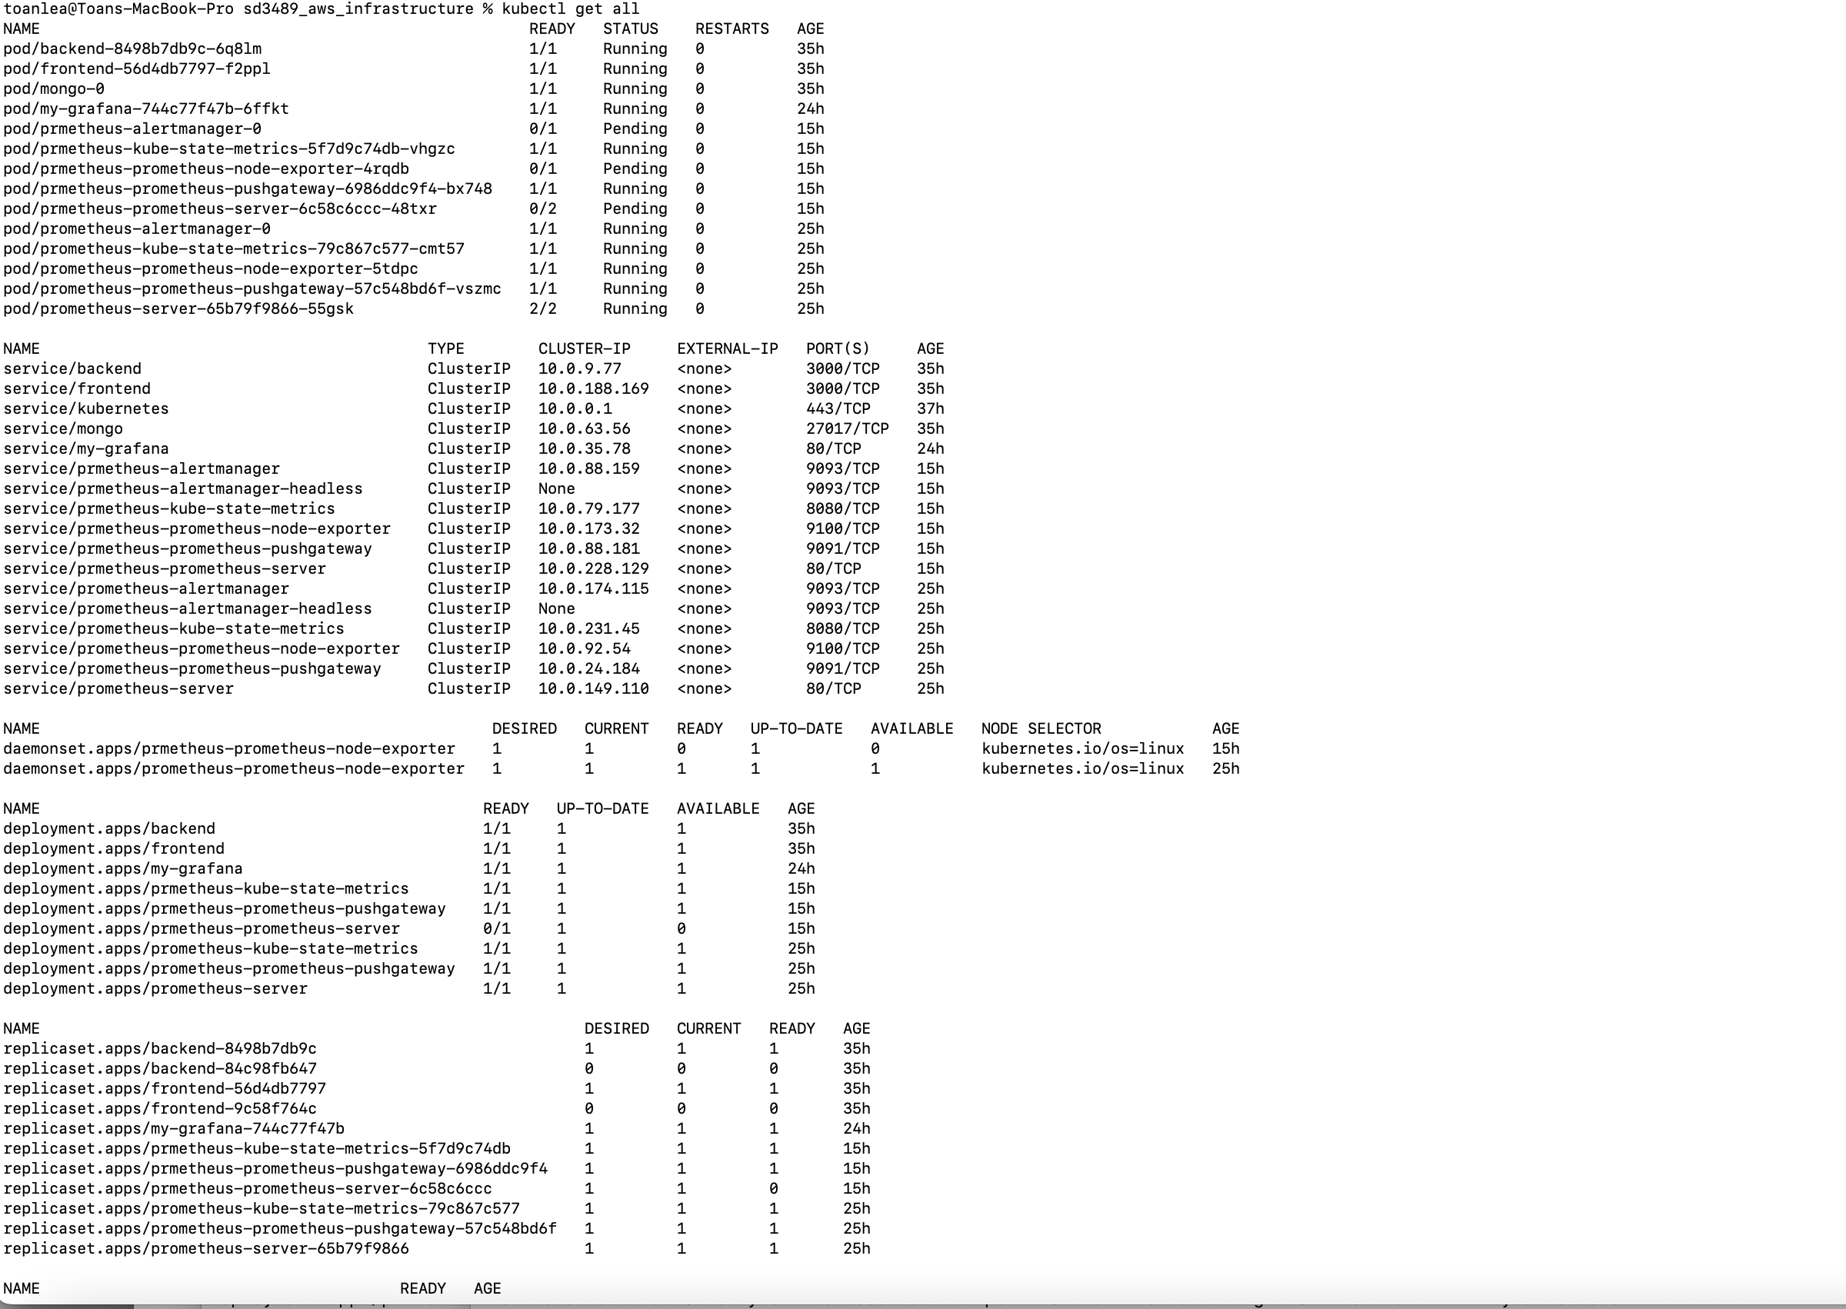

# [7] Monitoring with Prometheus and Grafana

## Install

* Please read README.md of <https://github.com/toan-le-theout/sd3489_msa>

Set port-forward and access Grafana UI

```

Kubectl port-forward [Grafana-service] host_port:container_port

```

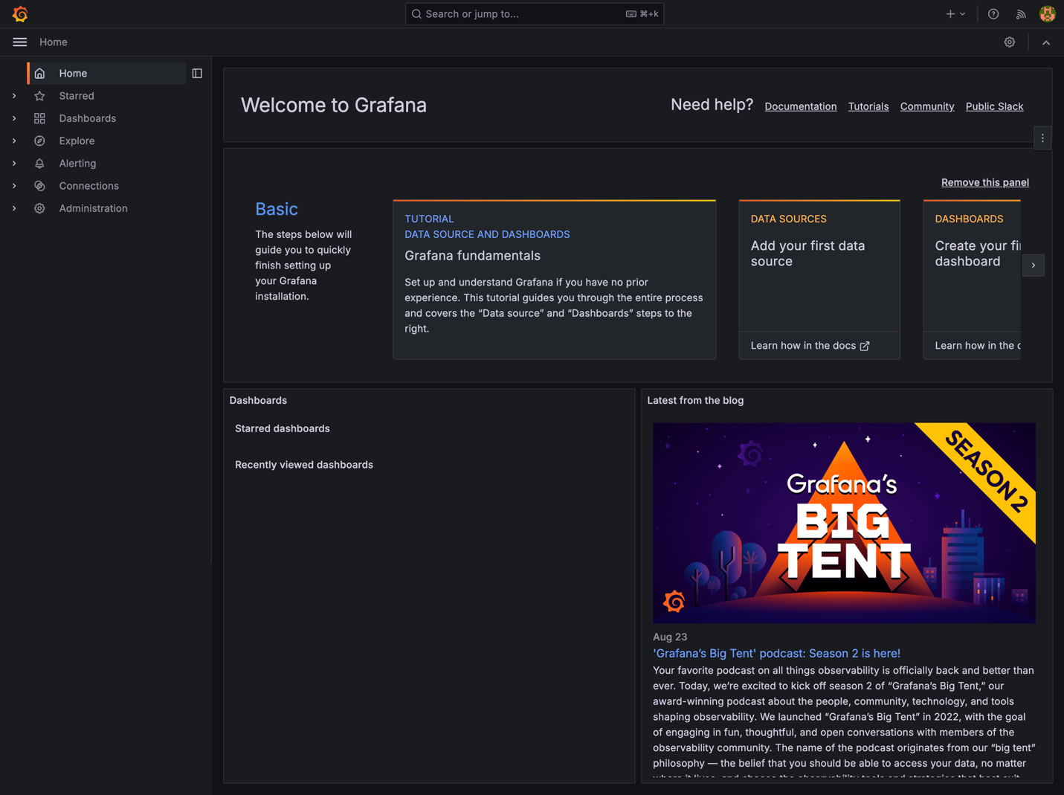

## Import metrics to Dashboard

## 

## Monitoring via UI (Dashboard)

